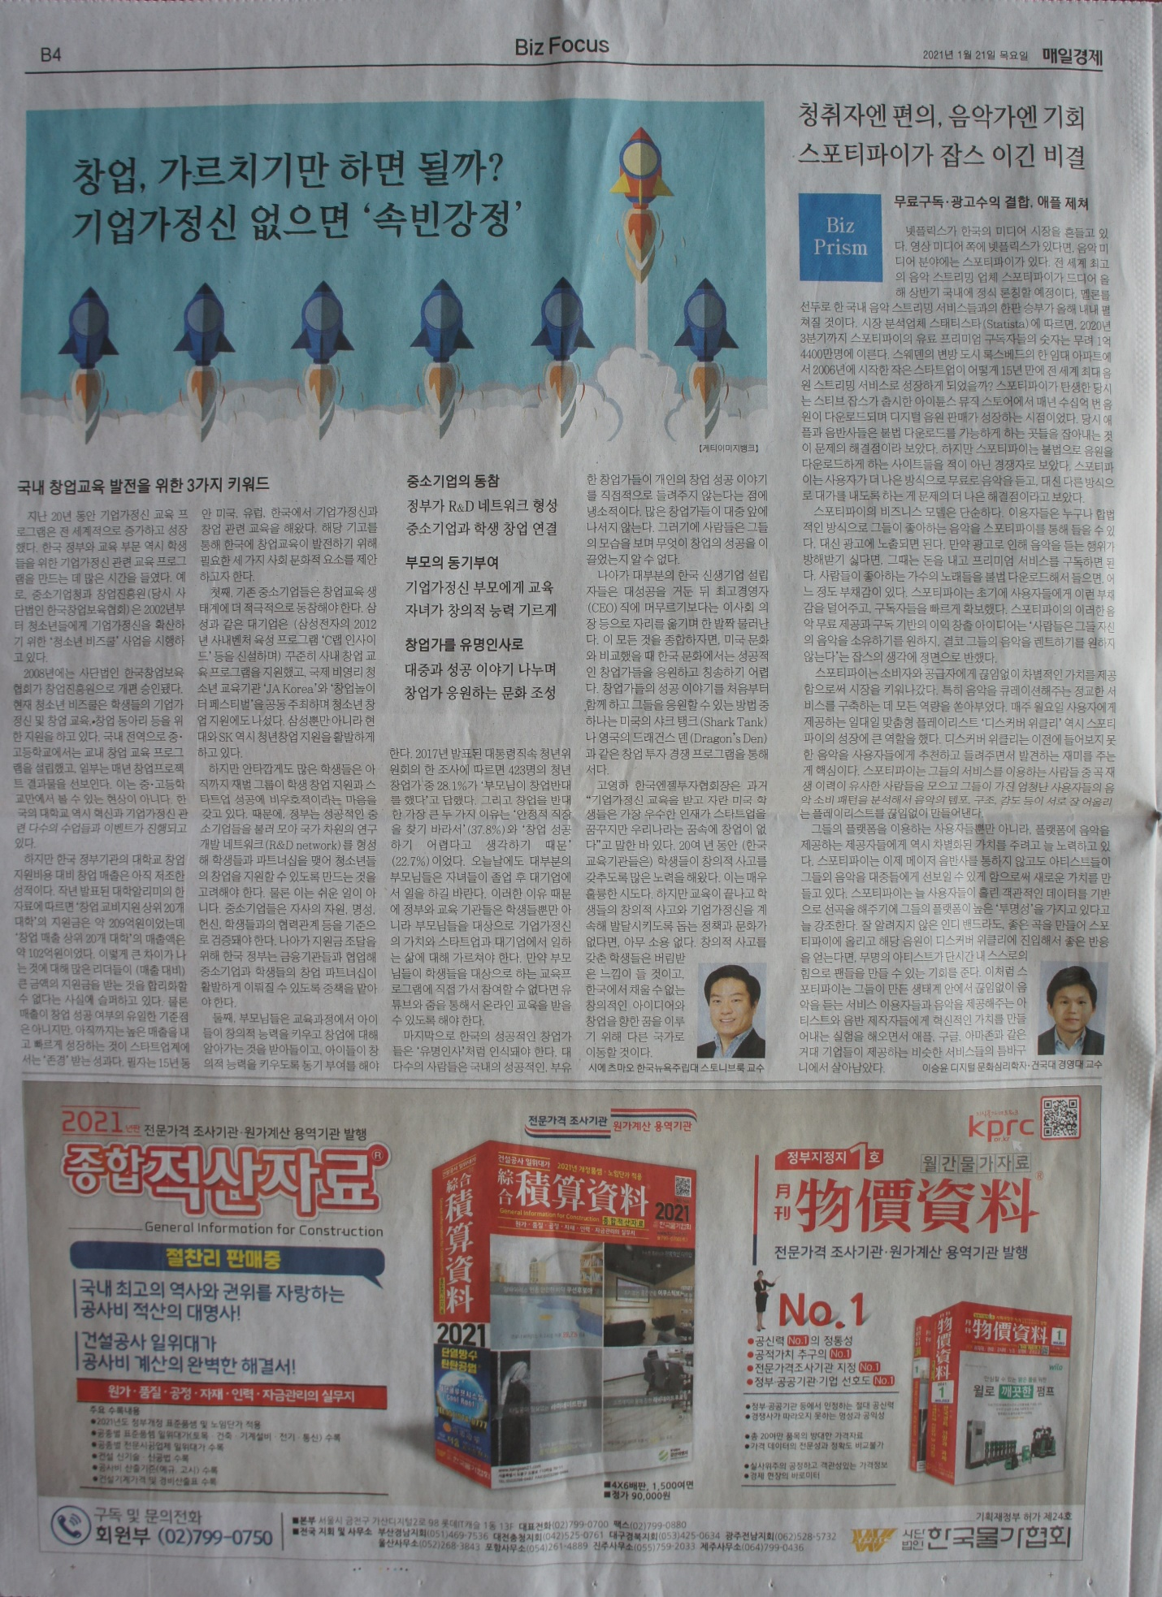
How Can Korea’s Social Culture Evolve to Support
its Entrepreneurship Education?
By Chihmao HSIEH (Korean spelling: (시에 츠마오)

Entrepreneurship training and education programs have grown exponentially around the world in the last two decades. Naturally, the government and educational sector in Korea have been busy creating programs for students. Since 2002, the Korean Ministry of SMEs and Startups has been implementing the “Youth Biz School” project to spread entrepreneurship to young people. Across all those years, about 3,700 schools have participated in that program. The Korea Institute of Startup & Entrepreneurship Development (KISED) was then launched in 2008 as a business incubator foundation, which now also adds a wide variety of entrepreneurship education and training programs. Middle schools and high schools all across Korea have created their own in-house entrepreneurship education programs, some yielding dozens of project-based outcomes every year. Today we can find good startup enthusiasm at dozens of Korean universities. Courses and educational events aiming to foster innovation and entrepreneurship are almost countless.
Yet, decades later, the entrepreneurship output at the highest educational level—the university—is still underwhelming. According to the Korea Herald Business Daily (미주헤럴드경제), government support for university entrepreneurship programming in Korea recently is around 209 억 KRW while the startup revenue during the equivalent period has only been 102 억 KRW. Startup revenue can certainly lag that programming expenditure, but many entrepreneurship ecosystem leaders still lament these days that the output cannot rationalize the educational expenditure. While revenue isn’t the only indicator of success in entrepreneurship education, rapidly growing innovative startups are still the most respected indicator. In part due to my experience as an entrepreneurship educator for 15 years in the USA, Europe, and now Korea, I can suggest 3 different sociocultural elements of the entrepreneurship ecosystem here in Korea that still require development, to fully appreciate the potential of its entrepreneurship education.
First, existing medium-sized enterprises should be more involved in the entrepreneurship education ecosystem. Large corporations like Samsung have steadily developed entrepreneurship and innovation programming that targets and benefits students, but chaebols alone cannot serve all the promising student ventures. While Samsung now has an in-house startup incubation program for its employees, and Hyundai and SK have recently partnered to nurture mobility and connected-car startups, many students today still have resistant pre-conceptions that Korean chaebols are unfriendly towards student entrepreneurship efforts and any startup success. The government should consider gathering successful medium-sized businesses into a national R&D network that can be leveraged to partner with new student startups. Of course, this is not easy. Those successful medium-sized businesses would ideally be vetted and certified in terms of their resources, commitment, reputation, and collegiality towards students. The Korean government should enlist and partner with financial institutions to play a larger role in developing innovative financing programs that stimulate partnerships between successful medium-sized enterprises and award-winning student startups.
Second, parents should become more willing to accept and motivate their children to develop their creative ability and explore entrepreneurship during schooling. In April 2017, the “Presidential Youth Committee” (대통령직속 청년위원회) conducted a survey of 423 young entrepreneurs, asking them about their parents’ attitudes towards their startup. 28.1% of those parents had objected to their children creating startups. From those parents, the top two reasons for opposing start-ups were that they wanted their children to find stable jobs (37.8%), and that they believed that startup success was difficult (22.7%). Many of today’s parents are still stuck on their children working for large stable chaebols like Samsung, LG, or Lotte, and some may furthermore subscribe to the cultural history where scholars and government officials tend to have a higher status than businesspeople (“양천제”). Government and educational programs should welcome parents to the learning process, educating them about the value of entrepreneurial thinking for worklife in startups and in today’s large corporations. Schools and entrepreneurship training programs should not always turn away parents after they drop off their children to these programs. Even if they are not allowed to physically join their children during educational sessions, in today’s Youtube and Zoom world, parents should still be offered some information access.
Lastly, Korea needs to find ways to give successful entrepreneurs some celebrity status and make them stronger positive role models. Maybe people are cynical that extremely rich and successful entrepreneurs are not very forthcoming in explaining their success. Many successful Korean entrepreneurs seem to hide from the public eye, so that their behavior cannot be monitored and scrutinized. Thus, instead of becoming celebrities, most Korean startup founders don’t usually stay on as CEO’s after tasting huge success; instead they often transition into the background as board directors or chairmen. Ultimately, there is very little opportunity to ‘cheerlead’ the successful entrepreneurs in Korean culture, as we see in American culture. Without those role models, students have one less source of inspiration. Dramatic angel-investment TV shows like the USA’s “Shark Tank” or the UK’s “Dragon’s Den” could be a good start.
Young-ha Koh, head of the Korea Business Angel Association, remarks that “The most talented American students who grow up receiving entrepreneurship education dream of launching start-ups, but Koreans have no dreams of start-ups.” For almost two decades, a lot of energy, attention, and resources have gone into changing the mindsets of kids here in Korea, in terms of fostering their abilities to think about how they can be creative, to think about how they think, and to re-frame the path to success. Those are wonderful attempts at development. But if broader Korean policy and culture cannot nurture entrepreneurial capabilities after that educational programming and training is over, then much of that effort will have been wasted. The most inspired kids may feel abandoned, remember that abandonment, and take their hungry innovative mindset to another country instead.

