By Chihmao HSIEH (Korean spelling: (시에 츠마오)

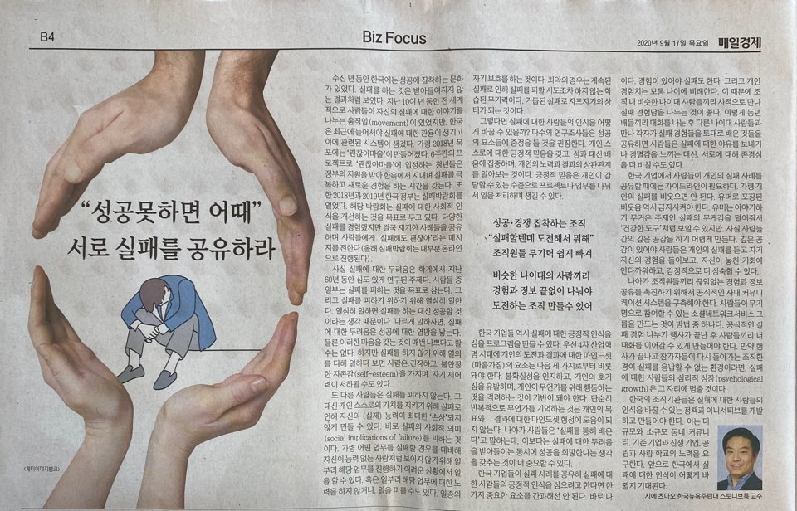
Changing the culture of failure in Korea

For decades, Korea has had a success-obsessed culture, where failure is supposedly not a valid or valuable outcome. While a global movement for sharing stories of failure has been growing for almost a decade, only in the last few years are we starting to see broad institutional reform here in Korea. Since 2018, a small community called “Don’t Worry Village” (괜찮아마을) was created in Mokpo with government funding that helps young South Koreans come together to embrace previous failures and experiment on their new ideas. In September 2018 and 2019, the Korean government sponsored and coordinated an annual “Fail Expo” (실패박람회), with aims to educate people to become more comfortable with self-challenge and failure. (This year, the Expo is held mainly from August until October, mostly online.) The design and experience of these events and initiatives can always benefit from additional understanding of the phenomena surrounding the fear of failure.

Fear of failure has been an actively researched topic for at least the last 60 years. Research suggests that some people have the main goal of avoiding failure, and they avoid failure by working hard to succeed. In other words, fear of failure exactly serves to drive success. That’s not always bad, but this mindset can involve unpleasant feelings of anxiety, unstable self-esteem, and perceptions of low control. Other people don’t try to avoid failure; instead they try to avoid the social implications of failure in order to protect their self-worth, by mitigating the extent to which failure reflects poorly on their ability. This could mean purposely reducing effort, engaging in little or no practice, procrastinating, or deliberately choosing crippling circumstances. Alternatively they set unrealistically low expectations, such that they cognitively and emotionally prepare themselves for the low-performing outcome. The result is a kind of self-protection: “I don’t care that you think I failed. I didn’t practice, I waited until the last moment, I wasn’t trying very hard, and I didn’t even expect to do well anyways.” At the worst extreme, some people accept failure to the point of ‘learned helplessness’ (학습된 무기력): they have given up so much that they don’t even care to make attempts that avoid failure.

Studies suggest focusing instead on ‘success orientations’. This includes developing strong positive self-belief (which can be fostered by breaking up projects or tasks into manageable components), focusing on learning instead of performance (i.e. via “peer tutoring”), and identifying the link between one’s effort and outcomes. Other research promotes the notion of ‘growth mindsets’, the idea that people will perform better if they believe—or are led to believe—that their intelligence can evolve. Presumably, a person will be more able to handle failure if they are re-assured that they are on the right path to growing and developing their intelligence.

While the abovementioned government initiatives are valuable, companies and organizations in Korea can also begin to design programming that inspires healthy attitudes towards failure. First, in the context of the demands of a 4th Industrial Revolution, mindsets about self-challenge (a goal) and failure (an outcome) should be driven by acknowledging uncertainty (a perception), promoting curiosity (an attitude), and encouraging individualistic experimentation (a behavior). Habits of rote memorization are not useful for this kind of learning process. And while people often talk about ‘embracing failure’ by appreciating the lessons learned, maybe it’s not always necessary to plan ahead to get the most out of the lesson. Too much planning can be wasteful and prohibitively stressful. At some point, it can be valuable to embrace ‘fear of failure’ together with ‘hope for success’, simply enjoying the suspense of the moment for its own sake.

Second, initiatives in Korea that attempt to stimulate knowledge-sharing about failure should be designed to consider major potential complications arising from differences in age. Failure emerges from experience, and amount of experience obviously correlates with age. Participants may benefit from being initially paired privately with similarly-aged people, whereby less formal communication will be excused and bilateral information sharing can be fostered, without suffering the judgment of bystanders. After participants have shared their experiences privately with each other, each pair can then gather together with other pairs from different age ranges. When these small groups present their insights to each other, we are likely to see greater respect for the kinds of lessons learned by a group, instead of inter-generational heckling (야유하다) and disdain (경멸감). Participants will be more active if there is more room to respect each other’s experience and learning process.

Third, events could offer a short set of guidelines for promoting a psychologically forgiving environment. For example, people shouldn’t be derided (비웃다) for their failure, even under the guise of humor. The use of humor in making light of each other’s failure can appear to be healthy, but is too often devoid of a deeper empathy that gives strangers or colleagues the chance to self-reflect, grieve over lost opportunity, and emotionally mature. A sense of humor is best applied overall to grow people’s confidence, not discount and erode it away. Fourth, organizers should formalize straightforward communication systems or protocols that promote ongoing information-sharing. Appreciation for failure and motivation for success can benefit from a dedicated private forum for participants to re-connect and offer emotional support after the event. That could be as simple as creating semi-anonymous SNS group chats, where organizers encourage attendees to follow up with each other personally in order to grow an understanding, resilient community. If attendees leave an event and return only to unforgiving environments, then an opportunity for lasting psychological growth has been unfortunately “left on the table”.

A movement is slowly building in Korea to reconceptualize the meaning, value, and culture of failure. Institutions here should continually develop and refine policies and initiatives that can change attitudes about those. All this will require compassionate effort from large and small communities, young and old companies, private and public schools. We should not wait to see how the situation unfolds.

